**DAS DIRECT ATTACHED STORAGE**

It is the normal storge system where the physical storge disk is directly connected to the system or server

Eg: SSD or hard disk in Laptops

**STORAGE CONTROLLER**

It is similar to an OS. It manages storage between CPU and physical storge disks. A storage controller is a critical component in a computer system that manages the flow of data between the CPU and storage devices like hard drives or SSDs. It acts as an intermediary, handling read and write requests, managing data access, and often incorporating features like caching and RAID for performance and data protection

**STORAGE MEDIA TYPES**

* SATA (Serial Advanced Technology Attachment) is a common interface for connecting storage devices like hard drives and SSDs to a computer.
* SCSI (Small Computer System Interface) is a High-performance interface, primarily used in servers and workstations. It Supports multiple devices on a single connection, high reliability and speed.
* NVMe (Non-Volatile Memory Express) is Modern interface designed for high-speed SSDs. It is Significantly faster than SATA, ideal for demanding applications.
* SCM Storage Class Memory
* SCM storage is an emerging technology with physical media which fits into memory slots
* SCM provides NVRAM (Non-Volatile RAM) rather than DRAM (Dynamic RAM) – it is persistent storage and survives power outages

**SAS VS SCSI**

* **SCSI (Small Computer System Interface):**
* Parallel Interface: Uses multiple wires to transmit data simultaneously.
* Multidrop Bus: Can connect multiple devices to a single bus, but this can lead to contention issues.
* Limited Length and Number of Devices: Has limitations on cable length and the number of devices that can be connected
* **SAS (Serial Attached SCSI):**
* Serial Interface: Transmits data one bit at a time, allowing for higher speeds and longer cable lengths.
* Point-to-Point: Each device has a dedicated connection to the initiator (controller), reducing contention.
* Higher Speed and Reliability: Generally faster and more reliable than SCSI.
* Hot-Pluggable: Allows devices to be added or removed without powering down the system
* 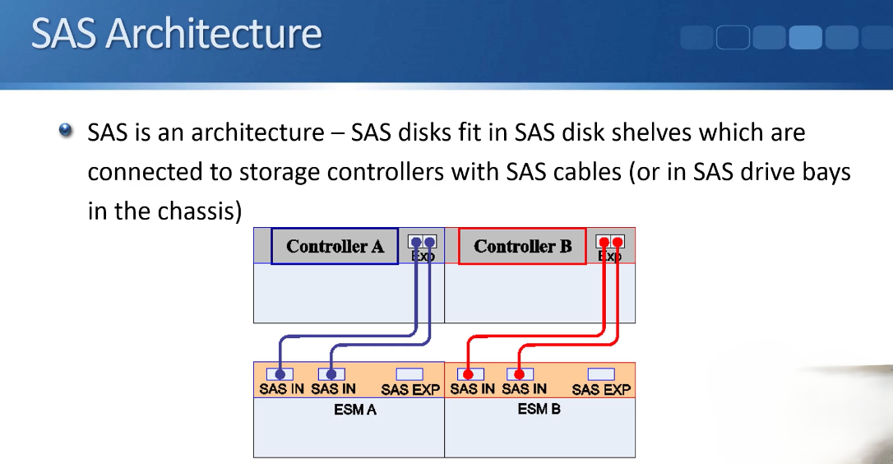SAS is an architecture, not just a type of disks.

**RAID**

* RAID stands for Redundant Array of Inexpensive Disks or Redundant Array of Independent Disks
* Multiple physical disks are combined into a single logical unit
* This provides redundancy, improved performance, or both when compared to a single disk
* Different RAID levels provide different levels of redundancy or performance
* RAID can be managed in software by the operating system or in hardware by a RAID controller
* Different disk types can't be put in same raid group but different size and speeds may be allowed to group in some system - although not recommendable
* Block-level striping is a RAID (Redundant Array of Independent Disks) technique where data is divided into blocks and distributed across multiple disks. This method enhances performance by allowing simultaneous read and write operations on different disks.
* Parity is a form of error detection and correction. In RAID, parity information is calculated for data blocks and stored on a separate disk (or distributed across multiple disks in other RAID levels). If a data disk fails, the parity information, along with the remaining data disks, can be used to reconstruct the lost data
* A dedicated parity disk is a component in some RAID configurations, specifically RAID 3 and RAID 4, where a single disk is solely responsible for storing parity information. This parity data is used to reconstruct lost data in case of a drive failure. While it enhances fault tolerance, the dedicated parity disk can become a bottleneck for write operations, as all write operations require accessing and updating this single disk

**RAID TYPES**

* RAID O
* RAID O is also known as a striped set
* Data is split evenly across all the disks in the set
* This provides better performance, but not redundancy

If any disk in the set fails, all the data is lost

* RAID 1
* RAID 1 is also known as a mirrored set
* A copy of the data is written to both disks in the set
* This provides redundancy. If one disks fails you still have a working copy of the data
* Write performance is not improved as a copy of the same data is written to both disks
* Read performance is improved as reads can be serviced by either disk
* RAID 2
* RAID 2 uses bit-level striping with dedicated Hamming code error-correcting disks
* Data can be reconstructed using error-correcting codes if a disk fails
* Read performance is high, but write performance is slowed by parity calculations
* RAID 3
* RAID 3 uses byte-level striping with a dedicated parity disk
* Data can be rebuilt from the parity disk if one drive fails
* Read performance is high for large sequential data, but write performance can be bottlenecked by the single parity disk
* RAID 4
* RAID 4 uses block level striping with a dedicated parity disk
* Data can be recreated from parity if any one of the disks in the set fails
* Read performance is improved as multiple disks concurrently service reads
* Write performance is not improved as all parity data is written to the same single disk
* RAID 5
* RAID 5 uses block level striping with distributed parity
* Data can be recreated from parity if any one of the disks in the set fails
* Read performance is improved as multiple disks concurrently service reads
* Write performance is also improved as parity data is spread throughout the set
* RAID 6
* RAID 6 uses block level striping with two parity blocks distributed throughout the set
* Data can be recreated from parity if two of the disks in the set fail
* Read and write performance is improved
* Hybrid RAID
* RAID levels can be nested into a hybrid RAID set
* In RAID 10 (1+0), multiple RAID 1 mirrored sets are nested into a RAID O striped set
* In RAID 0+1, multiple RAID 0 sets are nested into a RAID 1 mirror
* In RAID 50 (5+0), multiple RAID 5 striped sets with parity are nested into a RAID 0 striped set

**SAN (STORAGE AREA NETWORK):**

* Mostly used in servers
* Dedicated Network:
* SAN uses a separate, high-speed network (often Fibre Channel) to connect servers directly to storage devices. Its file system is managed by client.
* Block-Level Storage:
* SAN provides access to storage at the block level, meaning the operating system sees the storage as if it were directly attached to the server.
* High Performance and Scalability:
* SAN is designed for high-performance applications and environments where scalability is crucial, such as large databases and virtualized environments.
* SAN requires a separate Network to connect the SAN storage to the client or the server
* SAN storage allows logical disk booting due to block level access - booting system without having a physical hard disk

Examples:

SANs are commonly used for database storage, virtualization, and enterprise applications

**NAS (NETWORK ATTACHED STORAGE):**

* Standard Network:
* NAS connects to a standard local area network (LAN) and uses protocols like TCP/IP for communication. Its file system is managed by remote storage system
* File-Level Storage:
* NAS provides access to storage at the file level, meaning users can access files and folders through a standard file system interface.
* Ease of Use and Cost-Effectiveness:
* NAS is generally easier to set up and manage than SAN, making it a more cost-effective solution for smaller businesses and home users.
* NAS uses the already available network to connect

Examples:

NAS is commonly used for file sharing, backup, and media storage

**FEATURES**

* Thick Provisioning:

Definition:

Allocates the full requested storage space at the time of creation, regardless of whether the space is actually used.

* Example:

If you create a 100GB thick provisioned virtual disk, it will immediately consume 100GB of physical storage, even if the VM only uses 20GB

* Thin Provisioning:

Definition:

Allocates storage space on demand, as data is written to the volume.

Example:

If you create a 100GB thin provisioned virtual disk, it might initially consume only a small amount of space, and grow dynamically as data is added

* storage tiering - Can storage hot (frequent access files) in high performance disk like SSD and cold (rarely access files) in low performance disks like sata to save costs.
* They are both centralized storage system which is accessed via the network
* centralized backup
* Both SAN and NAS can be used in modern systems
* virtual machine and servers can be moved to another physical server without turning it off
* example: if physical a and b servers has each 3 virtual machines, when A servers need maintenance, the virtual machines can be moved to b without even having to turn them off.